Name: Mpho Mugogovhali
Proposal 2: Love Books
- Organisation overview
Love Books is a cozy independent bookstore tucked inside the Bamboo Lifestyle Centre at 53 Rustenburg Road, Melville, Johannesburg. Jaci Jenkins and Kate Rogan opened it back in 2009, and since then it’s become a favourite spot for local book lovers. The shop stocks a carefully picked range of books, and you can either shop online or visit in person. Their website also keeps readers updated with book launches, new titles, and upcoming literary events (Sayegh, 2018).
Love Books welcomes all kinds of readers, adults, kids, and anyone interested in both South African and international books. Their online store offers a wide mix, from fiction and non-fiction to children’s books and more
- Website Goals, Objectives and KPIs
The new website aims to increase Love Books’ online presence and make it easier for customers to browse books, stay informed about events, and contact the store. Key goals are to present the bookstore’s range clearly, promote literary events, keep store information up to date, and encourage more interaction online. We’ll measure success using 3 KPIs: monthly website visitors, number of book and product inquiries, and total questions or event-related inquiries received.
- Current Website Analysis
Love Books runs a fully working website with an online shop, updates on new books, information about events, and a contact form (Love Books, 2023). For this student project, we’ll build a simplified version of the website instead of copying every feature from the current commercial site. The site will use a simple 5-page structure focused on the organization, selected products, events, and contact information.
- Proposed Website Features and Functionality
The new website will consist of five main pages: Home, About, Books, Enquiry, and Contact.
Home: Welcomes visitors to Love Books and highlights featured books and upcoming literary events.
About: Tells the story and values behind the bookstore.
Books: Allows users to browse different book categories and titles.
Enquiry: Lets customers ask questions about books, events, or services.
Contact: Provides the store address, phone number, opening hours, and location map.
Based on the current Love Books site, users can already browse books, purchase vouchers, submit enquiries, and view events (Love Books, 2023).
- Design and User Experience
The site will capture the cozy feel of an independent bookstore. We’ll use a palette of cream, dark green, muted brown, and burgundy to create a classic, readable look. For typography, body text will use a clean sans-serif font while headings use a distinctive serif to give it that literary character. Large images of books, clear categories, and simple navigation will make it easy for visitors to find what they need.
- Technical Requirement
The website will be built using HTML5 for structure. CSS and JavaScript will be added in later development phases. We’ll use Visual Studio Code as our code editor. To launch the site, we’ll need a domain name, web hosting, an SSL certificate, and a modern browser for testing. As this is an academic prototype, it will not include the full e-commerce features found on the current Love Books website.
- Timeline and Milestones
Week | Milestone
Week 1 | Organisation research, proposal, sitemap and wireframes
Week 2 | HTML structure and website content
Week 3 | CSS styling and responsive layout
Week 4 | Testing, corrections and final documentation

- Sitemap
- Home:
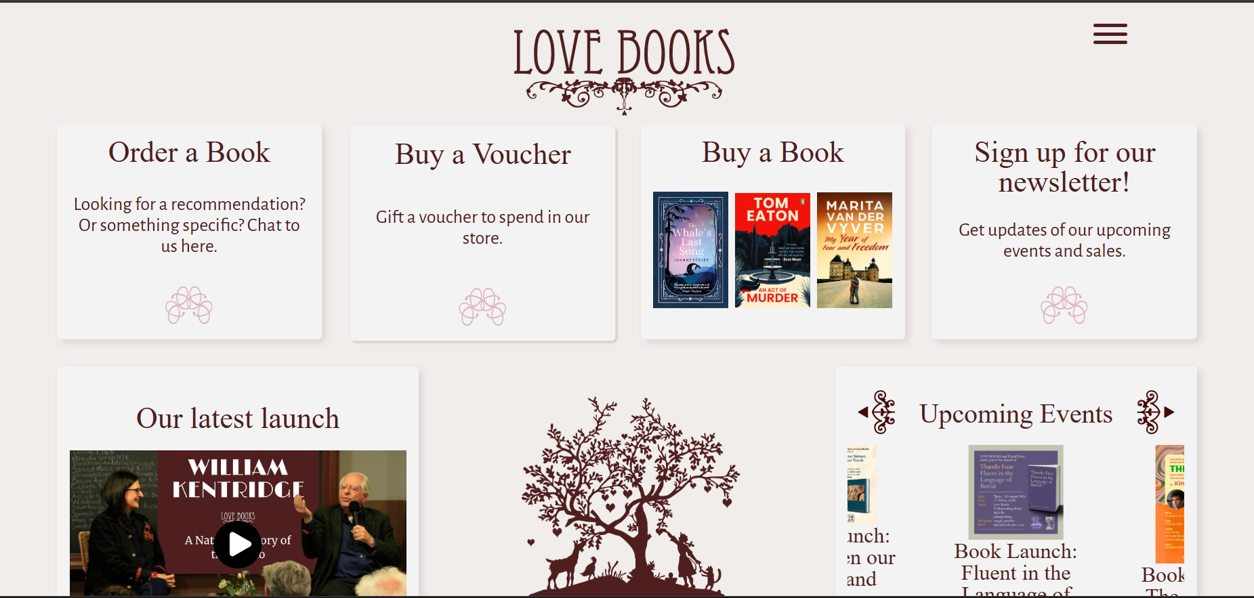

References:
Love Books. (2023). [online] Love Books. Available at: https://lovebooks.co.za/ [Accessed 13 Aug. 2026].
Sayegh, M. (2018). The survival of a bookshop in an evolving and artsy Melville. [online] Wits Vuvuzela - Produced by Wits Honours in Journalism students. Available at: https://witsvuvuzela.com/2018/11/11/the-survival-of-a-bookshop-in-an-evolving-and-artsy-melville/ [Accessed 14 Aug. 2026].

